**A Simple Tic-Tac-Toe Game**

1. **Objectives:**

To build a simple multiplayer tic-tac-toe game with coloured marking of squares.

1. **Target Platforms and availability:**

Android devices with version 4.0 and up.

1. **Features:**
   1. Coloured marking of squares.
   2. Automatic reset of grid in case of a tie or win.
   3. Provision for player names input and change.
   4. A score tracker with persistent tracking across various sessions of the games.
   5. A button to reset the scores.
2. **Possible additions to the project:**
   1. A colour picker can be provided for choosing the marking scheme.
   2. Social authentications can be maintained for keeping track of scores across various devices.
3. **Implementation factors:**

Target OS will be android and more suitable for devices with a long screen.

1. **Screenshots:**
   1. **Main view:**

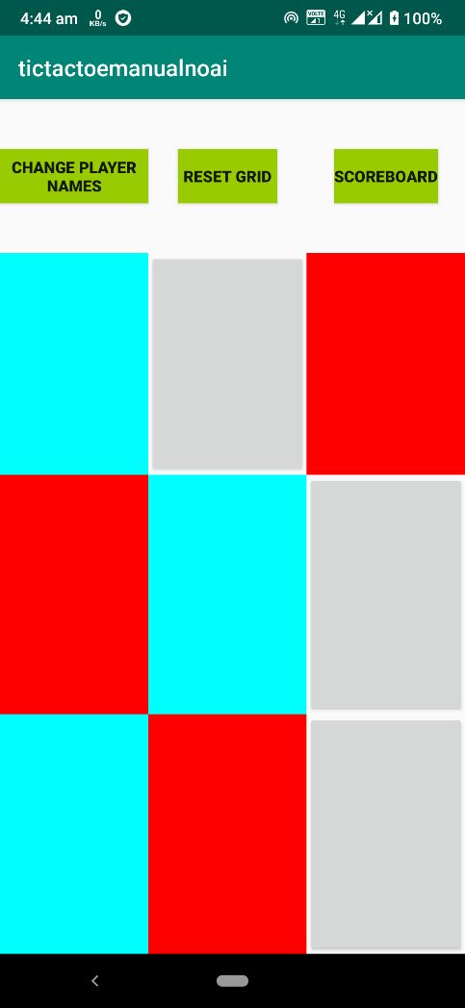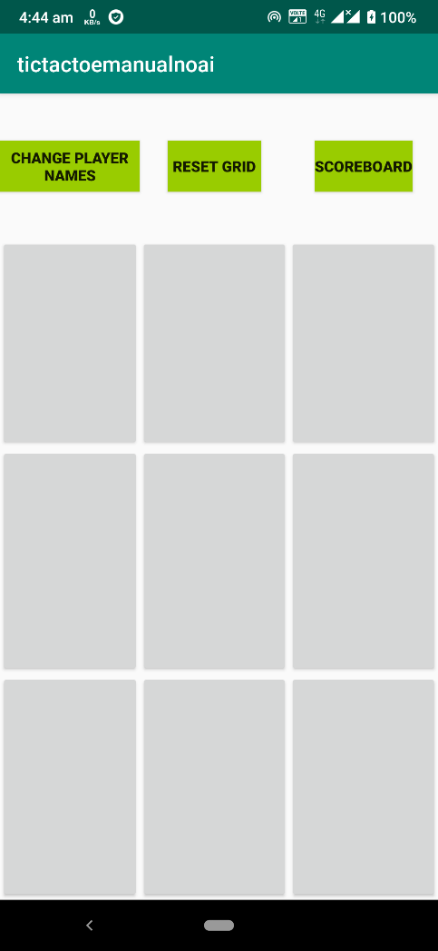

* 1. **Scoreboard:**

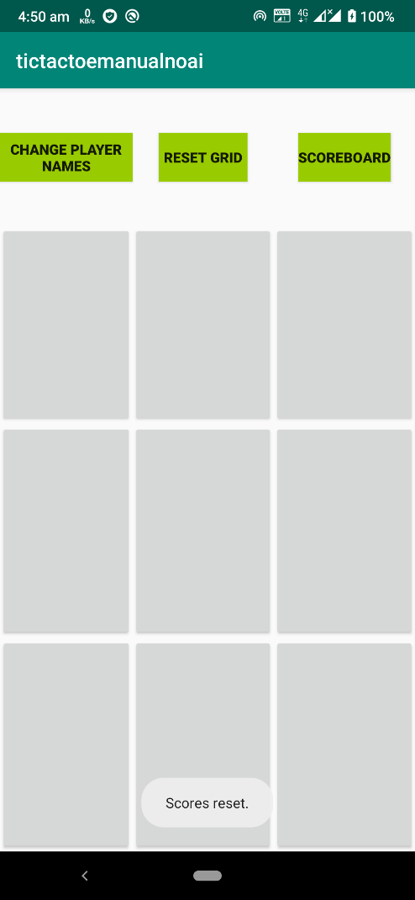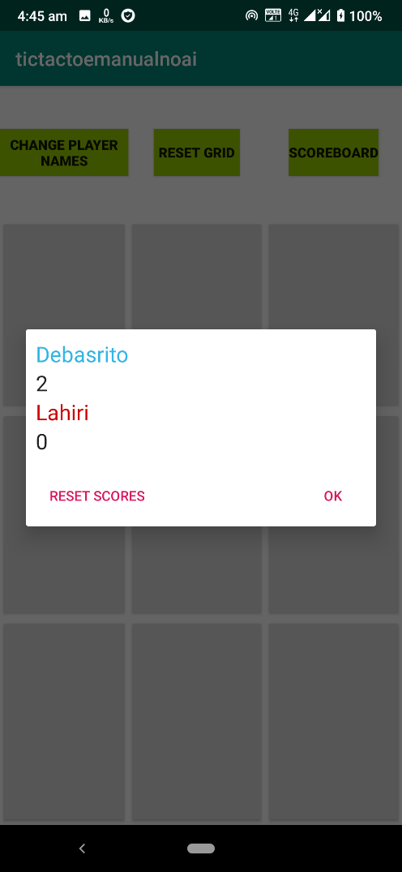

* 1. **Player names input:**

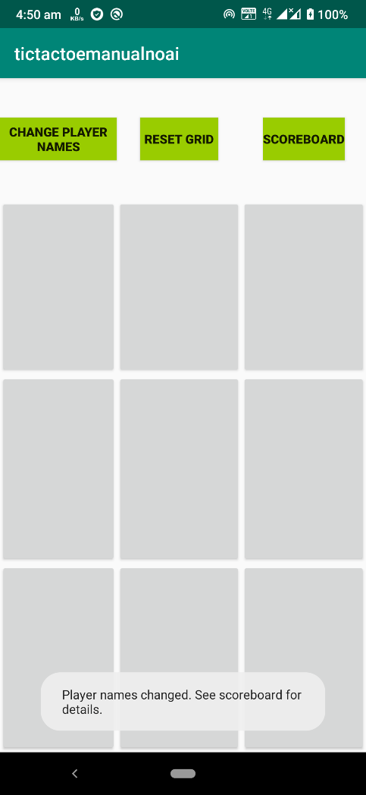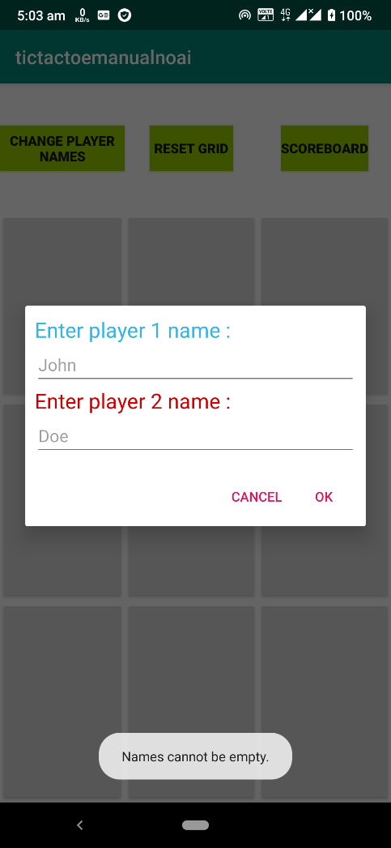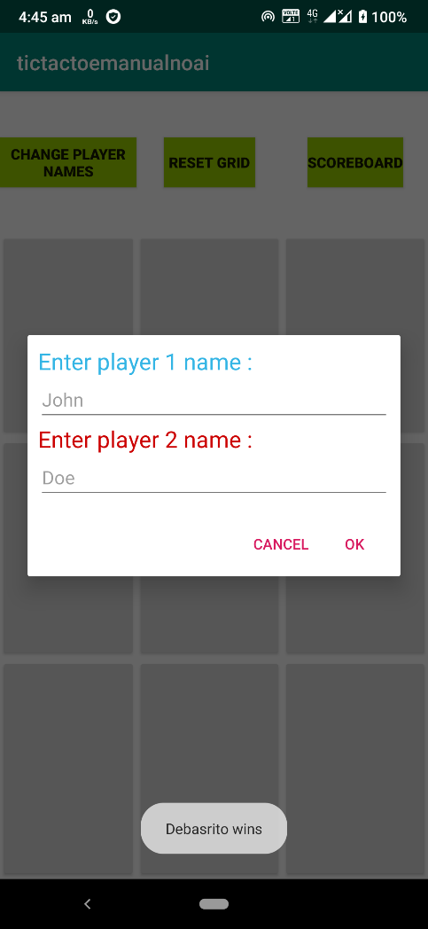

* 1. **Win/draw notification:**

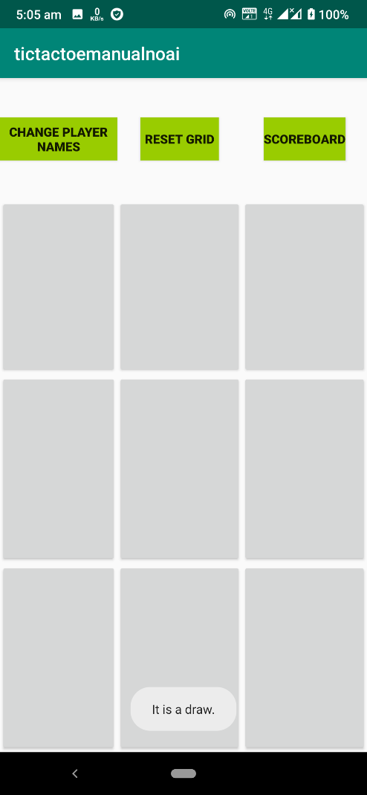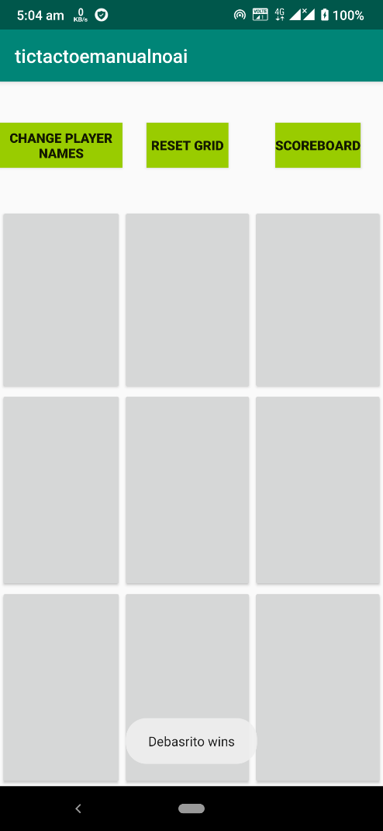

* 1. **Manually resetting the grid:**

